Intern Data Access and Email Handling Policy
Approved by: Louise McMahon
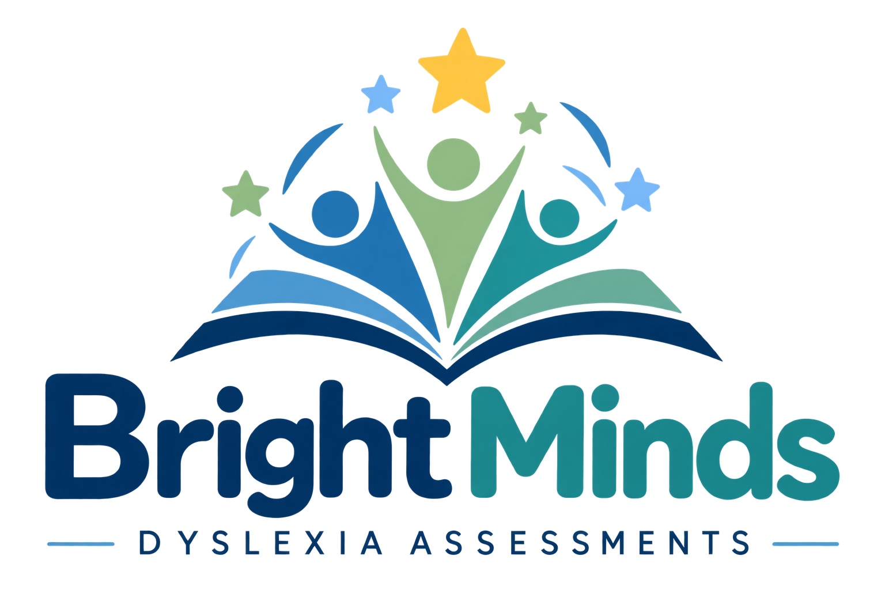

1. Purpose
This policy ensures that staff members only access personal data and emails when necessary for their duties, and that such access is lawful, proportionate, and secure in accordance with the UK GDPR and the Data Protection Act 2018.

2. Scope
This policy applies to all staff, internsor temporary placements; all systems, emails, documents, and data under the control of Bright Minds and all personal data processed, including names, contact details, and special category data.

3. Principles
- Lawfulness, fairness and transparency
- Purpose limitation – only for assigned work tasks
- Data minimisation – access only what is necessary
- Accuracy
- Storage limitation – data must not be retained unnecessarily
- Integrity and confidentiality – appropriate technical and organisational security

4. Roles and Responsibilities
All staff must:
- Complete mandatory data protection and confidentiality training before starting work;
- Only access or process personal data for approved tasks;
- Keep all information confidential;
- Report any accidental or unauthorised access immediately.
The Data Protection Officer (DPO) must:
- Maintain a record of intern data access permissions;
- Audit compliance and investigate breaches;
- Provide advice and guidance on handling sensitive information.

5. Access Controls
- Staff will be given individual user accounts with role-based permissions.
- Access will be limited to specific folders, systems, or mailboxes relevant to their work.
- All access to systems containing personal data will be logged and auditable.
- Multi-factor authentication (MFA) will be used where available.

6. Handling of Emails and Sensitive Data
- Staff must not forward or copy emails containing personal data to external accounts or personal devices.
- Sensitive or special category data may only be viewed with supervisor approval.
- If data is shared internally, it should be anonymised or minimised where possible.
- All files and emails must be stored on secure, approved systems.

7. Confidentiality Agreement
All staff members must sign a Confidentiality and Data Handling Agreement before being granted access. Breach of this agreement may result in disciplinary action or termination of placement.

8. Data Breach and Incident Reporting
- Any unauthorised access, loss, or disclosure must be reported immediately to the supervisor or DPO.
- The DPO will assess and record the incident in the organisation’s Data Breach Register.
- Where applicable, the DPO will notify the ICO within 72 hours and affected individuals without undue delay.

9. Review and Monitoring
This policy will be reviewed annually by the DPO and updated to reflect any changes in legislation, ICO guidance, or organisational structure.
I acknowledge that I have reviewed and comprehended this information, and I will handle all details with strict confidentiality.

SIgned: ____________

